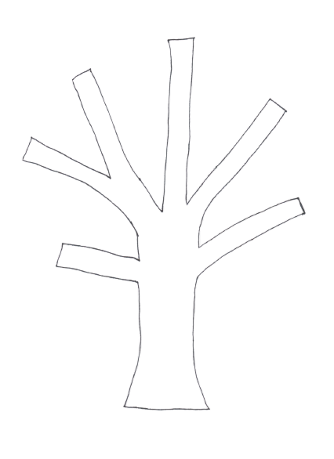

Use these patterns to cut your animals for your applique’. You may choose the small or the larger leopard. You do not have to use both. If you would like, you may cut two tortoises, one for Mr. and Mrs. Tortoise.

