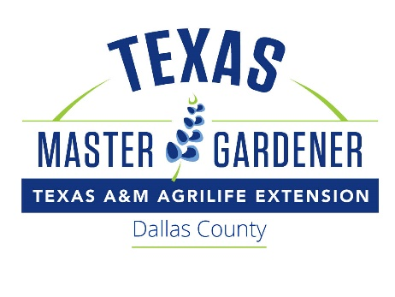

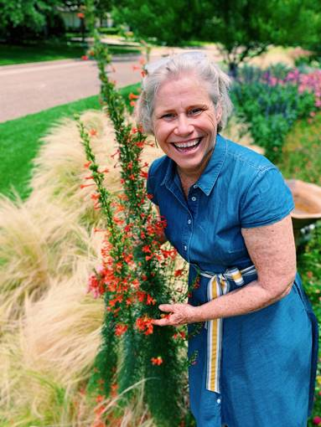

# GINA WOODS

Contact: Dallas County Master Gardeners Speakers Bureau

To book a speaker:

https://dallascountymastergardeners.org/get-help/speakers-bureau/

Personal Statement

Gina became interested in gardening when she moved to a ranch in Mexico in 1987. She was fascinated with orchids and wanted to have a career even though job opportunities were limited in rural Mexico for an American who could not speak the language. In 1991 she built her first two orchid shade houses and became the first commercial, cut-flower dendrobium orchid producer in Mexico. In the following 19 years, Gina expanded into plant rentals and events, and opened a retail location in Tampico, Mexico. In 2010 Gina returned to Dallas and founded a new company, Tropical Essence LLC, which specializes in exotic tropical plants. In 2013 she co-founded Yardspell LLC, which specializes in water-wise landscaping and provides personal and commercial gardening services. Gina and her daughter work together as Mother Daughter Earth; they provide environmental education through podcasts, blogs and Instagram. In addition to her love for orchids and other plants, Gina has a passion for education and also enjoys reading, entertaining, and hiking.

Gina speaks on orchids, bromeliads, tillandsias, succulents and cacti, and native and adapted plants.

CERTIFICATIONS:

TEXAS MASTER GARDENER, Dallas County

Native Plant Landscaping and Maintenance (Native Plant Society of Texas)

Home garden is a Certified Wildlife Habitat (National Wildlife Federation)

member of and/or works with THE following horticulture organizations

(includes offices held):

Dallas Flower Show Judges Founders Group (former Vice President)

Garden Masters (Founding Member)

Greater DFW Bromeliad Society (former Vice President)

Designers with Flair Study Club (former President)

Designers and Diggers Garden Study Club (former Vice President)

NGC Flower Show Judge

EDUCATION:

Graduate: The Hockaday School, 1979

BBA, University of Texas at Austin, 1982