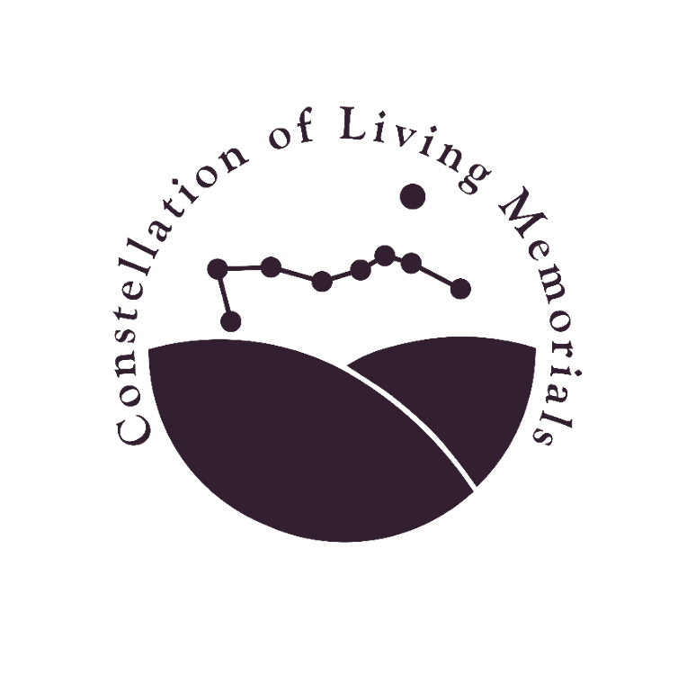
The Circle of Life
The Constellation of Living Memorials Public Art Initiative
(Dallas Public Library - Pleasant Grove branch)

Objective

- To foster community engagement through a public art event that will inspire one’s connection to self, community, nature, and ancestors.
- To enlighten the community about creating greenspace and natural habitats within old and forgotten cemeteries.
- To experience how art can promote dialogue in the reimagining of historic cemeteries for community engagement.

Desired Outcome

- Community neighborhoods are in the forefront of what is becoming a grassroots movement on a state and national level. The front page of the New York Times recently ran a newspaper article titled Life After Death: America’s Cemeteries Are Rewilding, November 29, 2024. This article referenced The Constellation of Living Memorials and Julie Fineman’s engagement with Dallas communities to create sustainable greenspace and wildlife habitats within old cemeteries. While these cemeteries were not listed by name in the article, the unnamed cemeteries include the Albert Carver Cemetery, Beeman Cemetery, Oakland Cemetery, Western Heights Cemetery, W.W. Glover Cemetery, and the Warren Ferris Cemetery in East Dallas.
- Through community engagement and the reimagining of these 6 historic cemeteries, pockets of native grasses and plants have been established to sustain wildlife, birds, bee pollinators, and monarch butterflies. With increased public awareness and more community volunteers, each cemetery has the potential to become a jewel in the midst of the community, as these natural habitats become central to the cemetery landscape.
- Like the imaginative, and yet-to-be-seen artwork that will be created for this exhibition, the intentional native landscaped cemeteries will be full of textures, sounds, colors, pollinators, and wildlife. Like the artwork, each season in the cemetery will produce surprises and new experiences, and further our dialogue and community engagement.

Pleasant Grove Library Exhibition

- Exhibition title: The Circle of Life
- Consists of approximately 25 individual house-shaped art panels that have been prepared for display on designated library shelves, to hang on the lower portion of the end cap of designated book aisles, and to view in the round.
- The installation of the exhibition will be coordinated with library staff in regards to visibility, traffic flow within the library, and safety.
- Lucy has offered to create an art guide to show where the artist's work has been placed. This guide will provide the artist’s name, title of the artwork, and location in the library.

Tentative Dates per Luz Benitz, Public Service Specialist 1 - Programming Liaison

- Promotional materials for the Circle of Life exhibition & Information Session due: 06/01/25. All promotional materials will include Spanish & English language.
- Constellation of Living Memorials and the Dallas Public Library will promote the Circle of Life exhibition, RSVP for the Information Session and art panel: 06/01/2025 - 08/31/25. RSVPs to be collected at the library’s front desk or through a QR code on the collateral.
- Tentative date for the Information Session: Saturday, 09/06/2025 Time: TBD
- Space is limited for this exhibition. RSVP for the Information Session and to receive an art panel at this time or prior via QR code or sign-up sheet.
- After the Information Session, any remaining art panels may be picked up at the library from 09/06/ 2025 - 09/15/2025).
- The library space allows for approximately 25 art panels in this exhibition.
- Timeline for completing Artwork: 09/06/2025 - 10/25/2025
- Date to submit artwork to the Library for exhibition: 10/26/2025
- The library will accept finished artwork earlier, if completed before 10/26/2025.
- Tentative Grand Opening/Reception: Saturday, 11/01/2025 Time: TBD
- The library can have a small party, reception, or a booth with information about our organization for participants and others to visit.
- Circle of Life exhibition: 11/01/ 2025 - 11/30/2025
- Timeline for artists to pick up their entries; 12/01/2025 - 12/07/2025.
- Any artwork that is remaining after 12/07/2025 will become the property of The Constellation of Living Memorials (CLM).

Eligibility

- Individuals: 14 years of age +
- Family Collaboration: parents and their children

Information Session: About Us

- A short background on the Friends of the Warren Ferris Cemetery, a discussion over a bowl of pea soup. Becoming a 501c3 non-profit.
- An evolution of an idea: The Constellation of Living Memorials, a project of The Friends of the Warren Ferris Cemetery.
- Why are natural habitats and greenspace important in today’s world and communities? How do they contribute to our physical and emotional health, as well as to our world at large?

Information Session: About the Art

- Your art piece might be serious, humorous, philosophical, or an homage to family and ancestors, etc.
- Your art piece might depict your love for animals, nature, spirituality, your interpretation of the circle of life, it might speak of icons in your neighborhood, restaurants, signs, billboards, music, or speak of the energy in your community, etc.
- Your art piece could be a collage of different photographs, or 3-dimensional objects, creating a wonderful assemblage of texture and color.
- Think about different ideas and have fun deciding what you are going to do.
- We are so excited to host this exhibition, and we are looking forward to making new discoveries through the eyes of others!

Information Session: Supporting Materials

- Projection Screen & Digital Projector TBD
- Binder, Poster Board with photographs, Constellation of Living Memorials booklet.
- 1-2 Tables (2 chairs) TBD
- Sign-in Sheet
- House-shaped art panels

To Do List - Constellation of Living Memorials (CLM)

- Number each house-shaped art panel. Create a numbered list. List the artist’s name and contact information with the corresponding numbered art panel when it is picked up.
- Create a submission form for each artwork: Artist name, title, medium, date.
- Create promotional material: Posters, announcement handouts, etc.
- Determine locations to place the promotional material.
- Determine how we will be informed, if pieces are meant to be free standing? Ask artists to notify CLM if the piece is meant to be free standing, and provide a photo of the final image.
- Create labels for each artwork: Artist name, title, medium, date
- Organize & gather Information Session materials
- Prepare for endcap hanging and free-standing installation.
- Confirm with Lucy that library staff will be able to distribute the art panels & fill out the artist forms.
- Confirm and plan a reception with Lucy’s input.

Additional Tentative Ideas

- Use our projection screen to project and play The Circle of Life, from the Lion King movie, prior to beginning our Information Session.
- If we have a short speech before the reception, we might play the Circle of Life again, before speaking.
- Set up a presentation table in the library foyer with a guest signing book, FWFC & CLM materials: the CLM booklet, binder of WFC photos, poster board.

