Truett Area Crime Watch & Ferguson Road Initiative
TRUETT AREA CRIME WATCH & FERGUSON ROAD INITIATIVE MEETING & WORKSHOP

THURSDAY, JANUARY 24, 2019

6:00 PM -7:30 PM

WHITE ROCK HILLS LIBRARY
9150 FERGUSON ROAD AT HIBISCUS

BRING A NEIGHBOR!

AGENDA

6:00-6:30 PM: TRUETT CRIME WATCH UPDATES, DALLAS POLICE DEPARTMENT & CODE COMPLINCE

6:30-7:15 PM: WORKSHOP ON FINDING YOUR WAY THROUGH THE DPD PUBLIC OPEN DATA PORTAL
(Learn to access active calls, offense reports, narratives, etc.) Bring your laptop, tablet, or bring material to take notes.

7:15PM-7:30
GET TO KNOW YOUR NEIGHBORS
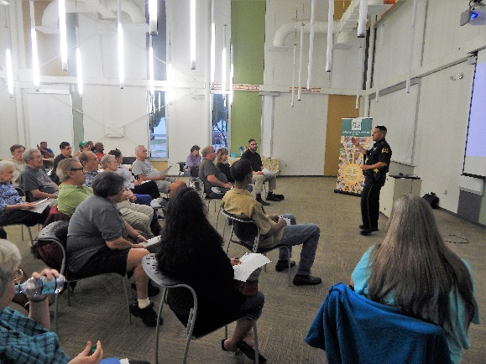

Leadership Team for Truett Area Crime Watch
tannerd994@gmail.com

